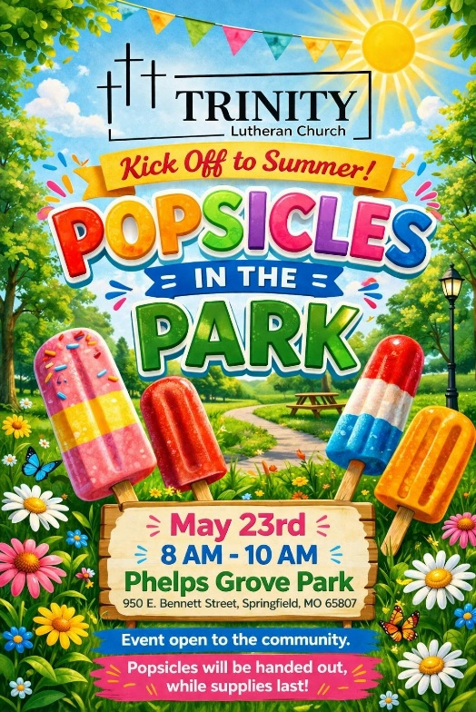
Popsicles in the Park – Volunteers Needed!
An exciting new community event is coming up at Trinity. Popsicles in the Park will take place at Phelps Grove Park on May 23, 2026, from 8:00 am to 10:00 am.
This event is designed to connect with our neighbors in a simple, welcoming way. We will be handing out free popsicles to park visitors while inviting them to learn more about Trinity and join us for worship.
All required permissions have been secured through the City, and we are ready to move forward. Now, we are looking for volunteers to help make this outreach a success.
Volunteers can assist with:
Social Media
-Greeting and engaging with park visitors
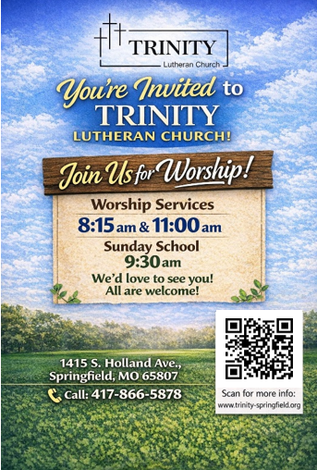
-Handing out popsicles
-Sharing information about Trinity
-Helping with setup and cleanup

If you are available and willing to serve, your presence will make a direct impact. This is a great opportunity to build relationships and represent Trinity in the community.
To sign up please call or text Jess Luna 417-818-4305

Postcard Flyers to hand out at the event

