**Faith Foundations 2025-2026**

**The Gospel of John (Part 2)**

**Introductory Session**

**Welcome to Faith Foundations! I (Pastor Nick Hagerman) am excited to be teaching this class with all of you again after being off for the summer months. I’ve had a lot of fun with Faith Foundations the past four years, and I hope all of you have as well. I’m looking forward to continuing this Bible study’s long tradition of in-depth, serious study of the Scriptures.**

**Faith Foundations is a women’s Bible study that approaches the Scriptures from the perspective of Lutheran theology. What this means is that, first of all, we consider the Scriptures to be the inspired, inerrant, and authoritative Word of God. We do not believe that the Bible makes mistakes or that Christians are free to ignore its teachings when something else suits them better. The Bible is the basis for all of the doctrines of the Lutheran Church, and thus it will be treated as such in this study.**



**The Lutheran Church also considers the confessional documents found in the Book of Concord (i.e.—the Augsburg Confession, Martin Luther’s Catechisms, the Smalcald Articles, and the Formula of Concord) to be a faithful and true exposition of the Word of God. Hence, these will sometimes be referenced in this class, as will some writings of church theologians. The traditions of the church can never replace Scripture, but they can aid us in its interpretation. The Lutheran Church values the contributions that learned theologians have made to the understanding of the Bible over the years, and so we will use those traditions discerningly as we study the Scriptures together.**



**During our previous year of Faith Foundations, we studied the first half of the Gospel of John. This year, we will read the second half of John and hear his version of the most significant events ever to happen in the history of the world. Some of the most famous and significant passages of Scripture are found in John’s Gospel, and Martin Luther counted it as his favorite one of the four. John contains some of Jesus’ most extended speeches and descriptions of who He was and what He had come to accomplish. Whereas the Synoptic Gospels (Matthew, Mark, and Luke) tend to make their points about Jesus’ identity implicitly, John is much more explicit. In some ways, one could regard John as “filling in the gaps” in our knowledge about Jesus, and thus providing us with a more complete and well-rounded understanding of His identity and work.**

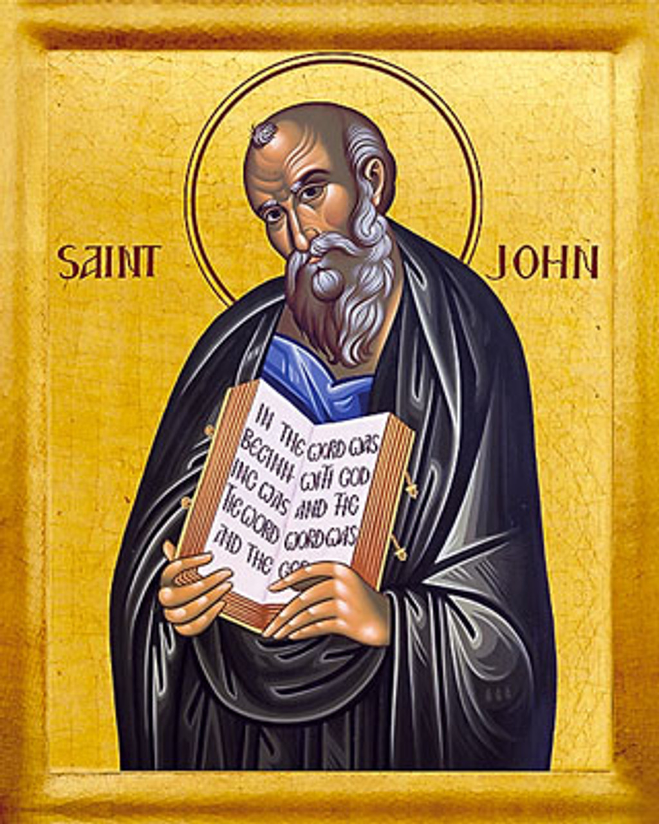

**Before we continue reading John’s Gospel, as a review from last year, it would behoove us to establish some facts about the book and its human author.**

**For starters, who was John? How was he connected with Jesus and His ministry?**

**The Synoptic Gospels give us quite a bit of information on John’s activities during Jesus’ ministry, as he was one of the most prominent of the original twelve disciples. Read Matthew 4:18-22, Mark 9:2-9, Mark 10:35-45, and Mark 14:32-42. What do these passages tell us about John the disciple?**

**John’s Gospel itself also gives us a great deal of information about John, but we will read those passages when we get to them in our study. In his own Gospel, does John refer to himself by name? What does he typically call himself?**

**The book of Acts also gives us one narrative from the time after Jesus’ resurrection that features John prominently. Read Acts 3:1-10, 4:1-4, and 4:13-22. What do we learn about John from these passages?**

**What do we know about the rest of John’s life and ministry as an apostle? From where do we get this information?**

**What other books of the Bible did John write?**

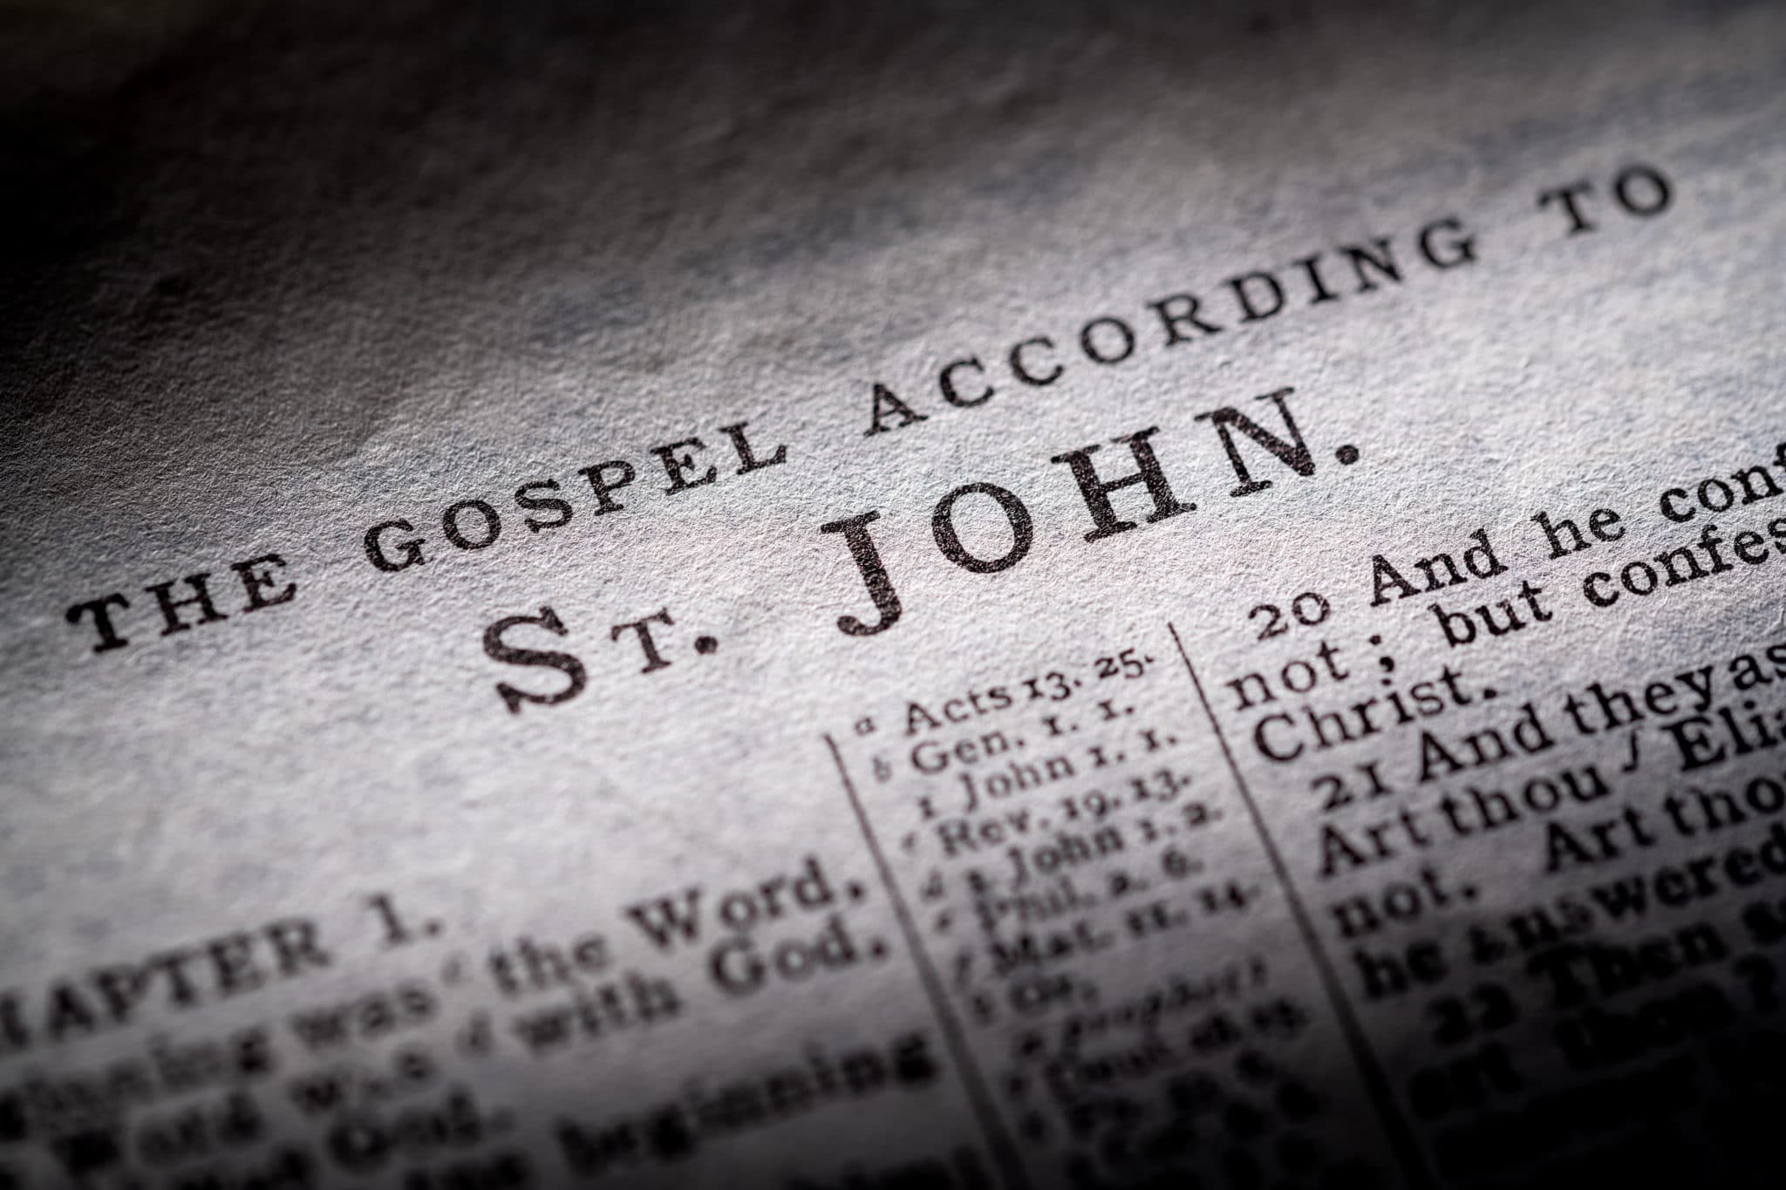

**As we can see, John played a highly important role in Jesus’ ministry and in the early church. Although he certainly was not perfect and made some mistakes, he boldly testified to the truth of Jesus’ resurrection from the dead and identity as the Son of God. In addition, his biblical writings made a significant impact upon the church of his day, and they continue to impact Christians almost two thousand years later. Our understanding of Jesus Christ and His work is greatly enhanced by John’s teaching, and as such we do well to continue to study it in the church today.**

**When we read John’s Gospel, we will see a number of significant themes interwoven through the narrative. Identifying and understanding those themes will help us to better receive the message of the Gospel as a whole.**

**Some significant themes in the Gospel of John:**

**1.) The divinity of Jesus Christ**

**2.) “Signs” as proof of Jesus’ identity**

**3.) The relationship between faith and sight**

**4.) Jesus’ “I am” statements**

**5.) Blood and water**

**6.) The work of the Holy Spirit**

**How is John’s Gospel fundamentally different from the Synoptic Gospels?**

**Despite the differences between John and the Synoptic Gospels, how are they all still similar?**

**This second year of our study of John will be a great opportunity for us to read the eyewitness testimony of a man who knew Jesus personally and saw all of the most significant things He did. John remained faithful and loyal to Jesus to the end, and He boldly confessed his faith in Him until his dying day. We are now invited to journey back with John through the life, ministry, death, and resurrection of Jesus Christ, and to be reminded anew of the lifesaving power of His work to bring us sinners back into fellowship with God. My prayer for all of us is that our faith in Christ will be strengthened and our understanding of God’s Word would increase through this experience. May He bless our study of the Gospel of John!**