

Trinity Trumpet
Trinity Lutheran Church
Springfield, Missouri
February 2026

WELCOME TO OUR TRINITY FAMILY!

MISSION STATEMENT
The family of Trinity Lutheran Church welcomes all people to share in the life of the Christian faith in worship, friendship, and service.

OUR CORE VALUES
Faithfulness to God’s Word . . . Integrity . . . Compassion . . . Family focused . . . Engagement in Service . . . Welcoming to all people . . . Fiscal responsibility & stewardship
VISION STATEMENT
The family of Trinity builds and nurtures the bonds of faith through love, learning, and sharing with others.

OUR CRITICAL TARGETS
Faithful Worship . . . Christian Education . . . Healthy Christian Homes . . . Caring Relationships in Christ . . Robust Community Connectivity & Outreach


Ash Wednesday, Feb. 18
Noon & 7:00 p.m.

Lenten Services Wednesdays
Feb. 25, March 4-25
Noon & 7:00 p.m.

8th Grade Confirmation
March 22
11:00 a.m.

Palm Sunday
March 29


Maundy Thursday
April 1
Noon & 7:00 p.m.

Good Friday
April 3
Noon & 7:00 p.m.

Holy Saturday
April 4
7:00 p.m.

Easter
April 5
7:00 a.m. & 10:00 a.m.

  Trinity Lutheran Church  1415 S. Holland Ave.  Springfield, MO 65807  Phone: 417-866-5878  www.trinity-springfield.org |  |  | TO GOD ALONE  BE THE GLORY!  - Devoted to Jesus Christ,  the Son of God and the Savior  and Lord of the World  - Devoted to God’s Word, teaching the pure doctrines of the faith  - Devoted to the Sacraments of  Holy Baptism and Holy Communion, through which the Holy Spirit blesses God’s people with His presence and His gifts.  - Devoted to Christian Fellowship and to loving and caring for each other  - Devoted to sharing the Gospel with all people  (Acts 2:42)
To contact our staff, call the church office or
Email: tlcoffice@trinitylutheranspfd.org

+ Rev. Dr. Nicholas Hagerman, Pastor
nhagerman@trinitylutheranspfd.org

+ Mr. Noah Oloff, Vicar
noloff@trinitylutheranspfd.org

+ Mr. Caleb Staehr, Director of Parish Music
cstaehr@trinitylutheranspfd.org

+ Mr. Daniel Duffy, Director of Christian
Education (DCE)
dduffy@trinitylutheranspfd.org

+ Mrs. Hannah Knehans, Director of Family Life
Ministry (DFLM)
hknehans@trinitylutheranspfd.org

+ Mrs. Angela Bruton, Office Manager
abruton@trinitylutheranspfd.org

+ Mrs. Amy Scheer, Administrative Assistant
ascheer@trinitylutheranspfd.org

Officers  President: Mickey Moore  Vice Pres: Daniel Straw  Secretary: Amy Scheer  Treasurer: Amy Collins  Asst. Treas: Larry Zahn | Mission & Ministry Council  Ev. & Mission: Jess Luna  Christian Care: Joni & Dave Sommerer  Fellowship: Melinda Brown  Stewardship: Vacant  Endowment: Ann Marie Baker  Trustee: Jeff Winter  Personnel: Jason Jones  Parish Ed.: Heather Newman  Elders: Kevin Scheer  Family Ministry: Vacant  Age-Based Ministry: Paul Hambrick | Your Board of Elders  Zone 1 (A/Bo) Johnny Dicks  Zone 2 (Br/C) Tim Peters  Zone 3 (DE) Cary Watson  Zone 4 (FG) Mark Jones  Zone 5 (HIJ) Brock Buerck  Zone 6 (KL) Josh Sexton  Zone 7 (M) Gordon Lane  Zone 8 (NOP) Clate Baker  Zone 9 (QR) Phillip Hackley  Zone 10 (S/Se) David Mitchell  Zone 11 (Sh/T) Kevin Scheer  Zone 12 (UVWXYZ) Ed Larson |  | Your Board of Parish Education  Chair: Matt Lundien  Member/ABS: Zeke Young  Member: Patrice Winter  Sunday School: Linda Young  Midweek School: Heather Newman  VBS: Claire Hagerman
Our Trinity Family Stewardship – January 25, 2026

Attendance: 8:15 a.m. cancelled Previous week: 145
11:00 a.m. 84 164

Tithes and Offerings:
Undesignated (General) Offerings $ 3,492.38
Designated Gifts
Debt Reduction $ 200.00 R&R Fund $ 200.00
Christian Care $ 200.00 Midweek Dinner $ 136.00
Total $ 736.00
Total Gifts $ 4,228.38

Sunday School and Adult Bible Class Cancelled for January 25

FROM PASTOR HAGERMAN

Dear Trinity Family,

Greetings to you in the name of our Lord and Savior Jesus Christ! With all of the recent developments in national politics concerning the issue of immigration, it is probably time for me, as the pastor of Trinity, to make some kind of public statement about the topic. I have largely refrained from doing so, because I truly believe that the particular situation in which our country now finds itself can be viewed with a number of legitimate perspectives, and I do not want to bind anyone’s consciences by insisting that we all view the issue in the same way. However, I also think it is important for me to provide some guidance that will help us all frame the issue properly in our hearts and minds, guided by Christian teachings and values. With that said, the following is the basic perspective that I believe is helpful to us as we consider the issue of immigration more broadly and the specific situations that arise as a result of it.
Whenever we Christians consider events that involve the enforcement of laws, there are three basic questions we need to ask ourselves. One, is the law itself a just law? Two, if so, is the law being enforced justly? And three, if the answer to either of those questions is no, what should Christians do in response? Each of these basic questions also opens itself up to various sub-questions depending upon the particular situation that is presenting itself.
For instance, regarding the question of whether a law is just, in this situation we need to ask ourselves, is it just for a country (such as the United States) to regulate how people migrate to it from foreign countries? Is it just for the U.S. to have laws that limit the amount of foreign immigration? Is it just for the U.S. to require rigorous vetting of aspiring immigrants, using such tools as application processes and citizenship tests? Is it just for the U.S. to deny residency or citizenship to potential immigrants, and what would be valid reasons for doing so? Is it just for the U.S. to deny social welfare services, driver’s licenses, and voting rights to those who are here illegally? Does the U.S. have a greater obligation to care for its own documented citizens than it does for immigrants who have not followed the established protocols?
If the answers to the above questions are “no,” then that presents us with a new set of questions. Should there be any standards or processes at all by which an immigrant would be allowed into the U.S., or should the country allow in anyone who wants to come? Should all immigrants, legal or not, be able to fully participate in the civic life and social welfare services of our country and communities, with no fear of legal repercussions for their means of entry into the U.S.? What would be the legal, societal, and financial implications for the U.S. and its citizens if the current laws were changed to be more permissive toward immigration?
But now let’s say, for the sake of argument, that we agree that the U.S.’s immigration laws are, on the whole, just. Then that opens us up to the second basic question about just enforcement of the laws. How would immigration laws be enforced justly? Is the process of deportation itself a just action? Is it just to uproot families from places where they have lived, sometimes for decades, and then move them to a country that some of them have never even visited? Is it just to deport someone who, other than initially coming to the U.S. illegally, has overall been a law-abiding resident of the country? Can deportation be just or unjust depending upon how it is administered? Is it ever just to use force or violence to deport someone, especially if that person is fleeing law enforcement agents or violently resisting apprehension himself? Is it just to use physical violence against those who would seek to prevent federal agents from enforcing just immigration laws? Is it even possible to enforce immigration law effectively without resorting to physical force (as it would be impossible to enforce pretty much any other law that requires arrests or apprehensions)? What concrete, better alternatives could we propose to what is currently happening in cities such as Minneapolis and Los Angeles?
Finally, let’s say for the sake of argument that we believe either that U.S. immigration laws are unjust or they are currently being enforced unjustly. The question then becomes, how do we respond? Is it appropriate for us to protest and make our voices heard? Is it appropriate for us to protest using profane language or violence? Is it appropriate to impede federal agents in their work, or to assist immigrants in evading and resisting them? If not, then what circumstances, if any, would need to change for these actions to become appropriate and justified? Is it wrong for us to be silent or sit on the sidelines if injustice is indeed occurring? What concrete changes to the laws or enforcement of them do we believe should happen in this situation, and what is our reasoning that leads us to these conclusions?
All of these questions are important, and we need to consider all of them as we formulate our response to current events. Right now, we live in an emotionally charged political environment, and sober, logical reflection on the issues is not a strength of our society right now. We Americans respond more viscerally to narratives and images than we do to logical arguments, but we need to try to set that tendency aside as we consider these problems. We need to hesitate before using rhetoric about brutal ICE agents or brainwashed protestors, and we need to stop and think before using emotionally manipulative comparisons to Nazi Germany or communist agitation. To be sure, if those comparisons are indeed appropriate, then perhaps they should be used, but we need to have good, well-thought-out reasons as to why we are using them.
Above all, we need to show charity to our Christian family, friends, and neighbors who may look at these issues differently than we do. If you read through and thought about every question I posed above, you will have seen that the answers to our current immigration problems are not simple, and they will not be able to be resolved to everyone’s satisfaction. Sincere Christians can and will disagree about the best approach to this issue, and it is not our responsibility to judge the faith or faithfulness of another based on his or her views of a complex topic. We simply do the best we can, considering our duty to respect the authorities God has placed over us along with the real human needs of people in our country, citizens and noncitizens alike. We should pray for God to give us appropriate wisdom, discernment, and compassion as we attempt to address the problems in our country today, and we should be thankful that our citizenship is ultimately in heaven, where we will have to deal with none of the effects of human sin or a fallen creation.
I hope that this article has been helpful to you as you consider the challenges facing our society right now. Of course, I have my own opinions about what is happening and what should be done, but as I said before, I do not wish to bind anyone’s consciences about an issue with multiple legitimate perspectives. I simply want everyone to consider the situation rationally, without descending into emotionally charged thinking and rhetoric that prevents constructive solutions and leads to violence, injury, or even death. There has already been too much unrest and violence because of these issues, and I want to avoid more of it if at all possible. Please join with me in praying for peace and understanding in our country, and commit yourselves to addressing the issues faithfully and constructively. As always, Jesus Christ is the hope of the world, and the Christian church is the body that proclaims this hope to all nations. May He grant us the strength of faith to show respect to the authorities, compassion to those who are hurting, and love to all as we seek to navigate this difficult time together as the body of Christ.

In Christ,
Pastor Hagerman

FROM VICAR OLOFF

Dear members,

The 7th grade confirmation class reminded me that the season of Lent is quickly approaching. The students wanted to know if I was giving anything up for Lent. There were the typical suggestions. Don’t eat sugar or go to the gym more often. I told them I would have to think about it and get back with an answer.
So this got me thinking about Lent and the church practice of prayer, fasting, and almsgiving during Lent, specifically fasting or as we would recognize it as giving something up. I understand the practice of Lenten sacrifice can be controversial among Lutherans. There is a thinking that doing additional “works” of giving up something or taking on something is equivalent to works righteousness, an attempt to show just how pious we really are before God. While there may be some individuals or groups that can take Lenten practices to a theological extreme, understanding the origins and historic practices of the Church can assist us when planning and preparing for our own Lenten practices.
There are two paths that developed into the Lent we know today. The first was the fast which preceded the Pascha or Passover. This fast developed into Holy Week. The second path is the preparation period prescribed for candidates of Holy Baptism. The remainder of the 40 days of Lent developed from this preparation period. Lent has a theme of baptism since the crucifixion and resurrection of Jesus are significant and central to baptism. In the season of Lent we meditate on and contemplate the baptism theme, ““to put off your old self, which belongs to your former manner of life and is corrupt through deceitful desires, and to be renewed in the spirit of your minds, and to put on the new self, created after the likeness of God in true righteousness and holiness” (Ephesians 4:22-24). During Holy Week there are numerous services that we attend. The central service, it could be argued, is the Easter climax. At this service individuals who have been going through catechesis training were baptized into the church. The baptism rite is still included in the service today to baptize individuals and as a remembrance of our own baptism.
The reason for a period of instruction and preparation prior to baptism in the early church is complicated and longer than we have time in this article. Suffice it to say that a combination of the persecution of early Christians along with beliefs that being a Christian was a complete transformation to how one conducted daily life necessitated periods of individual scrutiny and instruction.
Another point to fly by, as it pertains to our discussion of Lenten traditions, is the number forty. The forty days of Lent, not counting Sundays, has historically been connected with Lenten fasting. Some churches practice shorter fasts of one day or fifteen days, but the practice of fasting has been strongly connected with the season of Lent. There are numerous reasons given why there is a 40 day fast. Tertullian, a second-century Church Father suggested forty commemorates the number of hours Jesus lay in the tomb. He remarked because Jesus Christ, the Bridegroom, was taken from the Church, His Bride, the church lamented, repented, and prepared for the Bridegroom's victorious return. Forty recalls numerous Biblical accounts such as Moses’ forty days on Mount Sinai (Exodus 24:18), the wandering of the Israelites in the wilderness for forty years (Exodus 16:35; Numbers 14:34; Deuteronomy 8:2), Elijah’s fast on the way to Horeb (1 Kings 19:8), and Jesus’ fasting and temptation in the wilderness following His Baptism (Matthew 4:1-2; Mark 1:13; Luke 4:1-2). It is important to note, The Lord’s Day (Sunday) was never part of the fast in the early church. That remains true today even though the worship service is muted without the Alleluias, Sunday is still a celebration of Christ’s resurrection and triumph over death and the Devil.
Reforms brought about by individuals such as Martin Luther attempting to recover the Gospel impacted Lent. The practices around Lent in the Church revolved around the sacrament of penance. The individual was to do penance in order to receive God’s forgiveness. Lutheran reformers emphasized that the work was already accomplished in Jesus. Lent was reoriented from focusing on the individual’s fasting and penitent practices to focusing on the accomplishments of Jesus on Good Friday and Easter morning. Rather than the church demanding one’s participation in Lenten practices, the Christian has liberty to participate in the Lenten fast because he or she desires to be closer to God, enhance his or her faith, and cultivate greater habits of love for the neighbor.
For Lutherans, Lent fasts (practices) are not something we do because we are required by some Law. We do not do them because we want to better ourselves as if Lent is a second attempt at our failed New Year’s resolutions. As Lutherans we observe Lenten fasts to reflect on what Christ has accomplished for us. The Lutheran commentator, Fred H. Lindemann, in a reflection on Romans 6:4 says, “The temporary interruption of some selfish habit for the limited period of Lent, with the intention of resuming the old habit after Easter, should not be encouraged… There is an element of danger in temporary observances. The spirit of work-righteousness or of appeasement may readily inject itself. Outward observances have their value, but to prevent a disastrous Lent the emphasis should be placed on the fact that Lent is a season for training in practices and virtues that are to be habitual and permanent in the life that is to be renewed at Easter." Saying I am going to not eat dessert for the 40 days of Lent, excluding Wednesdays for the good desserts and Sundays because that is the Lord’s Day, is selfish and inward thinking. Deciding that I will workout more or not drink alcohol through the season of Lent, with the intention of resuming the habit afterwards makes the season nothing more than a January 1st resolution that will come and go as leaves in the wind. The focus is squarely on me and what I want a rather sinful podium to stand on.
I do want to point out, the Holy Spirit does work in mysterious ways. I may say I will ride my bike to work with the intention that just because it is Lent I really should give up the comfy car ride. By the end of the forty days I am able to breathe better and have more energy to do things with my family and in the church. The Holy Spirit can use our own selfish intentions and turn us to focus more on Jesus.
So how should I answer the 7th graders? I think about when I was in 7th grade, I committed myself to only eat dessert on Wednesday during the soup suppers. That was, of course, when some of the best desserts were available and I did not want to miss out on those desserts. You can point out how selfish this was, yes; yet was a perhaps greater flaw in this plan. My family was not regular dessert eaters. My Mom did not prepare a dessert for every meal. I really was not giving something up. My practice of sacrificing desserts was temporary only developed so that I could have a superficial attitude of Lenten penance.
Our Lenten traditions are not as grand or spectacular as the early church. Our understanding of Lenten practices has changed as we focus on the Gospel and what Jesus has done for us. Even so, we can still use Lenten practices to focus our attention on the reason Jesus came to dwell with us and to develop habits and virtues that become a permanent example of being a Christian neighbor. Lent is a period to prepare for Good Friday and realize a somber contemplation of Christ’s suffering and death. This combines self-examination, repentance, and a desire to grow in faith. We are not attempting to focus on general better life habits, self-improvement, or to look good in front of others. Those are things that just need to happen whether it is the season of Lent or the season of Pentecost. So just floss your teeth because that is what needs to happen to have a healthy mouth. We do not fast because we are mandated by church law. We live on the other side of the resurrection.
I once heard that our Lenten practices should take something on instead of giving something up. While not all bad I want to make one edit. I think our Lenten practices should take on Christ while giving something up. This seems to fit a more historic view and even Lutheran of Lenten practices. Lent is a time to focus and prepare for Christ’s suffering and death. It is a time to reflect on what your baptism means for you. Changing your life so much that it is unrecognizable by replacing something with Christ is a great way to prepare for Good Friday and your daily Christian life. If you are caught in a sinful habit like pornography, Lent is a time to focus on Christ and drop the habit and replace it with being active in a community improvement project. You are free to enjoy Shrove Tuesday and then not eat fat for the remainder of Lent, while at the same time increasing your daily prayers. You can go to the gym and work out, but instead of listening to music, put on an audio version of the Bible or memorize the Small Catechism. You can give up TV and fill that time in devotion and hymn singing. Gather together as a community and help hold each other up while you walk through this season of Lent.
So enough beating around the bush. What am I giving up and taking on for Lent? This year I thought because I spend so much time watching YouTube for no reason other than because it is there, I will take that time to improve my devotional life and Biblical languages. I am interested in what you do for Lent and why. I like to hear about other traditions people have or other things people do during this season. I encourage you, even if you do not want to give something up, to take on Christ and be more mindful of how His suffering, death, and resurrection impacts you personally and your daily life. We can help each other grow our faith through these Lenten practices.

In Christ,
Vicar Oloff

FROM DCE DUFFY
Hello Trinity,

I was at a conference this past week for DCEs in Boca Raton, Florida. The conference theme was “Rest Assured”. Before leaving on the trip, I was not sure what to expect, but having the flu was not something I had considered. Here I will share with you what my experience was, how it was beneficial, and my big takeaways from the conference.

I arrived in Fort Lauderdale, Florida with nothing on my mind but lying down in bed for a nap. The ocean, the beach, and the Florida sun all seemed so trivial at that moment. After I finally got to my room I spent the rest of the evening attempting to make myself feel well enough to attend the conference the following day. Tea, sleep, hot shower, exercise, sunshine, whatever it took.

I woke up on Wednesday morning feeling a bit better, so I made my way to the breakfast cafeteria. There I realized what this conference was really all about. It wasn’t to learn the latest trends in ministry or to go to Florida to distract you from real life for a while, it was about connecting with friends you haven’t seen since college, dining with folks you were in ministry with years ago, and making brand new relationships with people who know the same Lutheran people you know. We ate together, sang together, learned together, all around the purpose of “resting assured”.

You may be wondering, especially if you’re an introvert, how what I described would be restful at all. For some, spending that much time around people sounds like a nightmare, but most of us in America today are desperate for connection. And the more connected through social media we are the more disconnected to reality we become. We complain about the kids these days always being on their phones, but if you look up it’s not just the kids. Opportunities to connect with people who share the same interests, values, and professional struggles is valuable for your mental, professional, and spiritual health.

Personally, what I took away from the conference is two things. First, connecting with old friends and new friends at a conference of people in your professional field is an enriching experience, and perhaps even worth fighting through the flu. Second, I found that what rest looks like can be different for all people, but what is most restful of all is removal of guilt and shame by repentance and receiving the gift of forgiveness through Jesus. Rest that is in Jesus is universal, eternal, and tops all other forms of rest. Praise God.

DCE Daniel Duffy

Adult Bible Study (ABS)
SUNDAY
Time | Topic | Leader | Location
9:45 AM | Bible Reading Journey | Pastor Biermann | Sanctuary
9:45 AM | 1 John | Bob Quebbeman | Woker Room
9:45 AM | Adult Confirmation Class | Pastor Hagerman | Church Office
9:45 AM | Gospel of Mark | Vicar Oloff | Gym
9:45 AM | Wrap up Kings followed by new study -- About the Prophets | Zeke Young | Room 2
9:45 AM | Senior High Youth | Josh Sexton | Youth Room, West Wing
MONDAY
9:15 AM | Faith Foundations | Pastor Hagerman | Gym and Mark Schultz Education Building, various rooms
WEDNESDAY
10:45 AM | Amos | Pastor Hagerman | Gym
6:30 PM | Luther’s Catechisms – Adult  Bible Study | Hannah Knehans | Family Room (Heilman Room)
6:30 PM | Senior High Youth Bible Study | Daniel Duffy | Youth Room, West Wing
THURSDAY
7:00 AM | Men’s Bible Study | Adam Breshears & Matthew Knehans | Room 2, Family Center
Adult Bible Class Descriptions

Bible Reading Journey - Continue your journey through the Bible in two years. Based on the reading plan in the Lutheran Study Bible from CPH, use handouts written by Rev. Dr. Todd Biermann to guide your study and home discussions. Continue to follow the reading plan on your own, and join the group for Bible Study and deeper discussion on Sundays. The location has changed to the Sanctuary.

1 John – "A loving and anxious sermon" written by a pastor who loved his people. This class is led by Dr. Bob Quebbeman in the Woker room, located in the Family Center.

The Gospel of Mark is a Gospel of action. It is the shortest of the Gospels and often is seen as the simplest, and least refined and developed. This is far from the truth. The Gospel of Mark is a powerful account of Jesus’ ministry and Passion. In this class we will walk through Mark, we will examine how the works of Jesus combine with His words to proclaim He is the Son of God in whom we can believe. Vicar Oloff will lead this study in the gym.

About The Prophets --Being an Old Testament prophet was not for the faint-hearted. Appointed by God to convey a message to a sometimes faithful, mostly obstinate people, these men- -and occasionally women- -navigated rough seas throughout their careers. Whether speaking of pending doom, future promise or both, familiar names like Jeremiah, Jonah, Micah, Isaiah, Daniel, Ezekiel, Amos, Malachi and others bore the weight of the world on their shoulders. Job security in this post was a sure thing, as Israel and Judah were constantly prompting God's righteous indignation by their wanton sins.
But it wasn't all harsh rebuke and humiliation for God's people. Amidst the clamor of bloody wars waged in Israel's and Judah's front yard by ancient Near Eastern superpowers like Assyria, Babylonia and Egypt, God sent a clarion call through the prophets for His children to repent. And there was more too, For the prophets were entrusted with the greatest news of all: that unto this people-- God's chosen ones--He was going to send a Savior, born of a woman, to redeem mankind from its sin. Facilitated by Zeke Young.

High School Bible Study – Sunday mornings Josh Sexton teaches our high school students (9th-12th grade).

Faith Foundations Women’s Bible Study – The Gospel of John (part 2) - The ladies of Faith Foundations will resume studying the Gospel of John. John's account of Jesus' ministry is very different from that of Matthew, Mark, and Luke: it recounts different events, includes different monologues and sayings of Jesus, and overall focuses the most on Jesus' divine identity as God in the flesh, come to dwell with His people. Countless Christians over the past two thousand years have found inspiration, joy, and hope in John's Gospel, and they will continue to do so until the day that Jesus returns in glory. Join us at Faith Foundations on Monday mornings so that you too may be encouraged by Jesus, whom John's Gospel describes as the living water, the bread of life, the light of the world, the Good Shepherd, and the resurrection and the life!

Amos - The book of Amos was written during the time when God's people were divided into the two kingdoms of Israel and Judah. Amos prophesied to the northern kingdom of Israel, which was on the brink of being conquered by the bloodthirsty Assyrian Empire as punishment for its sins against the true God. Amos spoke God's Word to the Israelites, pleading with them to repent of their sins before it was too late. Join us on Wednesday mornings this spring as we read through this often neglected Old Testament book and hear what the prophet has to say about sin, repentance, social justice, and the grace of God toward His people.

Luther’s Catechisms -- In this Wednesday night class, all Trinity adults will learn more about the main teachings of Christian doctrine (the 10 Commandments, Creed, Lord’s Prayer, and more). We will also discuss how to use and apply these doctrines at home in worship and devotion and in conversations throughout your daily life. This class will be especially helpful for the parents of our 3rd-8th graders as you learn more about the Catechism together. Led by Hannah Knehans, DFLM

Senior High Youth – Each Wednesday night the senior high youth meet in the youth room at 6:00 p.m. for a Bible study, fellowship and games. Led by Daniel Duffy, DCE



January 2026 Council Meeting Summary
The initial council meeting for 2026 included a general welcome to all new members as well as an observed thankfulness for those that have served and completed their terms. Pastor Todd Biermann attended in his role as Executive Director of Concordia Center for the Family, to request the assistance and support of TLC regarding Overtures to the Synod that will emphasize the work of CCF alongside the Synod but in a separate role as a Recognized Service Organization, and increase awareness of the same. Council has voted to support these Overtures as they are presented to the appropriate committee in advance of the Synod Convention. Mickey Moore, President, expressed his goals for this new role, and his experience with / excitement for the upcoming strategic planning for our congregation. Called workers and committee leaders shared verbal / written reports of recent and planned activities. Highlights of these include the following: musical ensembles and instrumentalists for Divine Service are resuming activities for the semester; all Age-Based groups enjoyed social Christmas festivities and are planning learning and fellowship opportunities for the coming year; the Board of Parish Education is planning an event for Sunday 3.22.26; the Family Life committee has worked to add a tv to provide the Divine Service live-stream in the cry-room for parents that utilize this space, and discussed the Baptism FLEA event recently held in the foyer; the Endowment Committee anticipates additional education for our younger members in addition to adults regarding the role of this committee, and will develop tools to assist in this educational focus; the Elders are welcoming 2 new members serving on this board, Gordon Lane and Ed Larson; Daniel Straw will serve as the Council representative on the Mark Schultz Scholarship committee for the coming year; other committees are developing plans appropriate to their focus, much of which is also highlighted here in the Trumpet. Please contact a council member regarding any other specific questions you may have.
Respectfully submitted,
Amy Scheer, Secretary




Trinity Women in Action (TWiA)

Thank you so much Trinity Congregation, for the Mite Offerings, which totaled $33.00. I Corinthians 3:9 - “Laborers together with God.” The LWML Mite collections will go towards, “Siouxland Lutheran Hispanic Ministry” (Hope Lutheran South Sioux City, NE). You can save your daily pocket change and we’ll collect for missions in the LARGE Purple Mite Box that will be displayed in the narthex on the second Sunday of each month. The next opportunity will be Sunday, February 8, 2026.

Trinity Women In Action College Scholarship Opportunity
Trinity’s young men and women who will be attending schools of higher learning affiliated with the Lutheran Church Missouri Synod may apply for a $300 scholarship for the upcoming school year. Students, you must submit a typed or handwritten letter stating the name of the college/university, the academic year in which the funds are needed, as well as a brief summary of how this scholarship will assist you in your career plans. TWIA encourages careers in church work, but it is not a requirement. Scholarship request letters should be mailed to Linda Oughton, 4602 Forest Ave., Springfield, MO 65810.



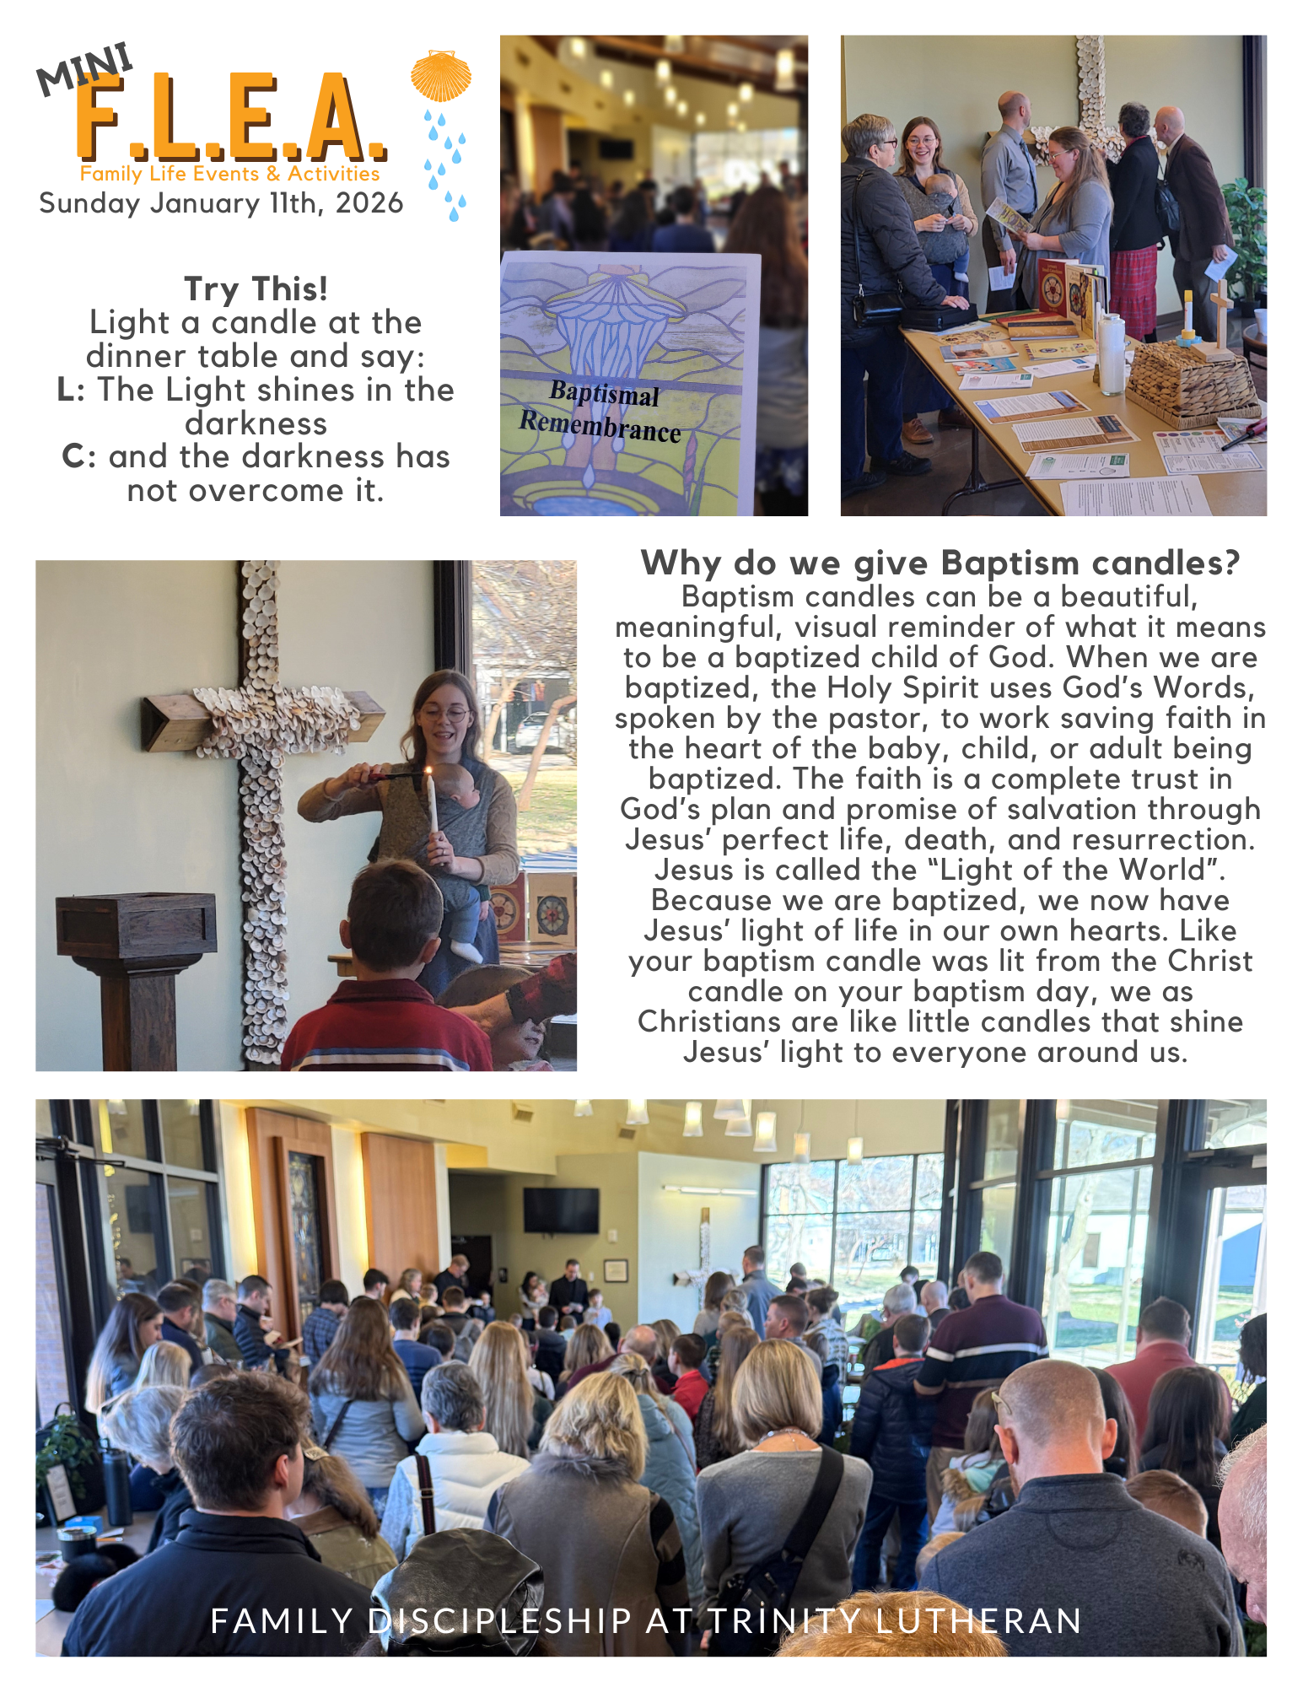
Stewardship Moment

Table of Duties: The Forgotten Stewardship Tool

Luther’s Small Catechism is a magnificent tool. Joined with a well-used copy of the Holy Scriptures and an orthodox hymnal, and the Christian is well equipped to live a life of faithfulness to the Lord and service to the neighbor. First in German and now in English and just about any language known to man, this handy masterpiece has introduced generations of people to the central doctrine of justification by grace, through faith, on account of Jesus Christ. The Six Chief Parts have proven to be a faithful framework for a clear confession of the truth of the Gospel for nearly five hundred years!

But more than a textbook, the Small Catechism also serves well as a handbook for Christian living. As a part of its treasure, there is an element that teaches an extraordinarily strong message of stewardship. That hidden treasure that needs to be rediscovered is called the Table of Duties.

The Table of Duties is really nothing more than a categorized gathering of Bible verses. These verses are set apart for “various holy orders and positions, admonishing them about their duties and responsibilities.” Addressing pastors and people, government and citizens, husbands, wives, children, youth, workers and so many more, it very clearly lays out what faithful stewardship looks like. Even better, these assembled passages teach one important truth: we are stewards of one another!

The Table is much more than a “how-to” tool; it also lays out the interconnectedness that exists within the body of Christ. Pastors are described by what they are to be as stewards of the Word. 1 Timothy 3 highlights the characteristics of a faithful pastor. Even more, Titus 1 highlights the need for the pastor to be faithful for the sake of those under his care.

Those who hear the faithful preaching of the pastor are stewards of the pastor as well. 1 Corinthians 9 talks about the need for the people to support the livelihood of the pastor. Galatians 6 talks about how the hearers share in the good things that the pastor teaches. 1 Timothy 6 talks about the honor that is owed to the pastor, not because of WHO he is, but rather WHAT he is teaching! Hebrews 13 shows the impact of this stewardship on the pastor, that they perform their duties with joy. Joyful pastors and people are always going to be better stewards of the Gospel!

Outside the church this interdependent stewardship is on display as well. Romans 13 highlights the respect necessary for the governing authorities. As citizens, the faithful steward is called to pay taxes (Matthew 22), pray for their leaders (1 Timothy 2) and that they should be ready to serve in the civil realm (Titus 3), because they are in these positions by God’s direction (1 Peter 2).

These steward duties are in the home too! 1 Peter 3 and Colossians 3 shape the husband steward. Ephesians 5 and 1 Peter 3 shape the wife steward. Ephesians 6 form parental stewards and child stewards.
The Table of Duties is a wonderful place for the individual steward to learn how much our stewardship is more than just a “me and Jesus thing!” In fact, it ends with these words: “Let each his lesson learn with care, and all the household well share fare.” This is interdependent stewardship on clear display. As each learns stewardship in this way, the more faithful we will be as a family, congregations, communities and the church at large.


Trinity’s Midweek School Program

5:00 p.m. – Dinner service begins-fellowship and gather around the table with your church family
5:45 p.m. – Kids of the Kingdom Choir for 3rd-6th graders led by Caleb Staehr
6:00 p.m. – Childcare begins, 7th & 8th grade class begins
6:00 p.m. – High School Bible Class with Daniel Duffy
6:00 p.m. – Kindergarten class and 1st-2nd grade class (Good News Crew)
6:20 p.m. – 3rd-6th graders head to class
6:30 p.m. – Adult Bible Class – “Luther’s Catechisms”

Upcoming Meal Plan
Feb. 4 Taco Bar Jen & crew
Feb. 11 Chicken strips and Mac & Cheese Laura & crew
Feb. 18 Homemade Pan Pizza Jen & crew
Feb. 25 Chicken alfredo pasta Laura & crew


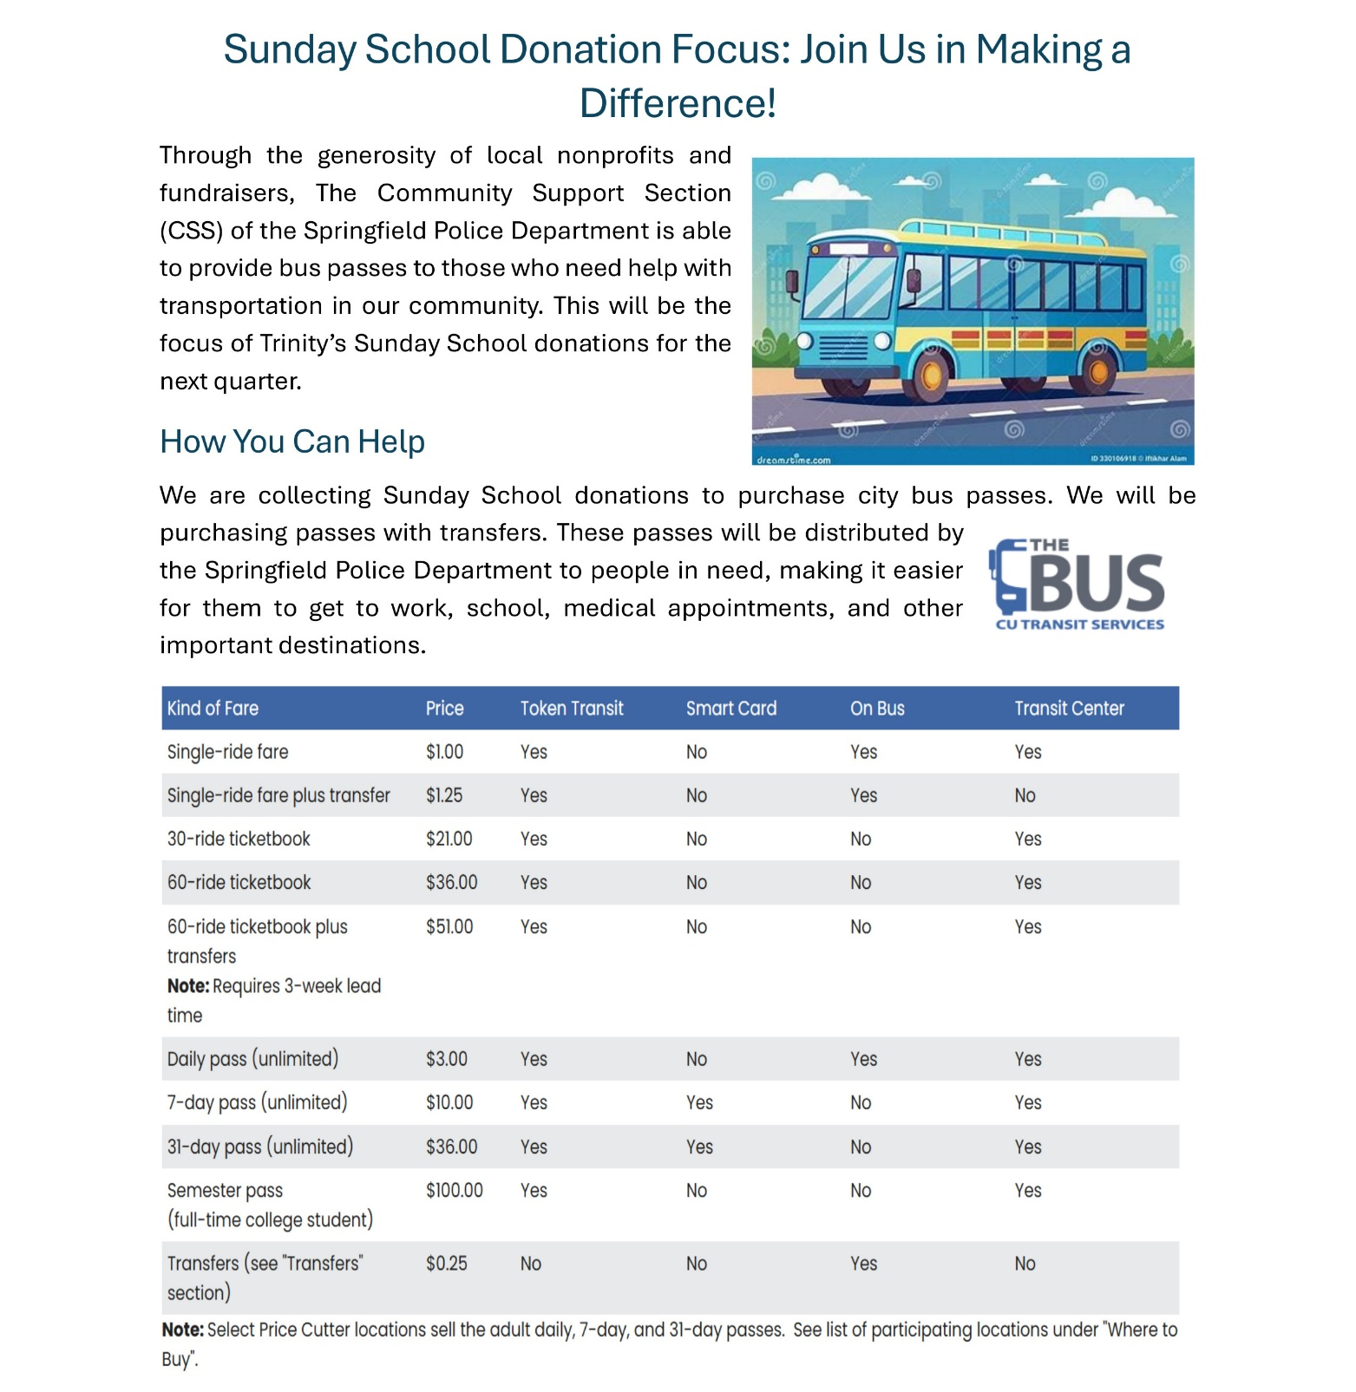

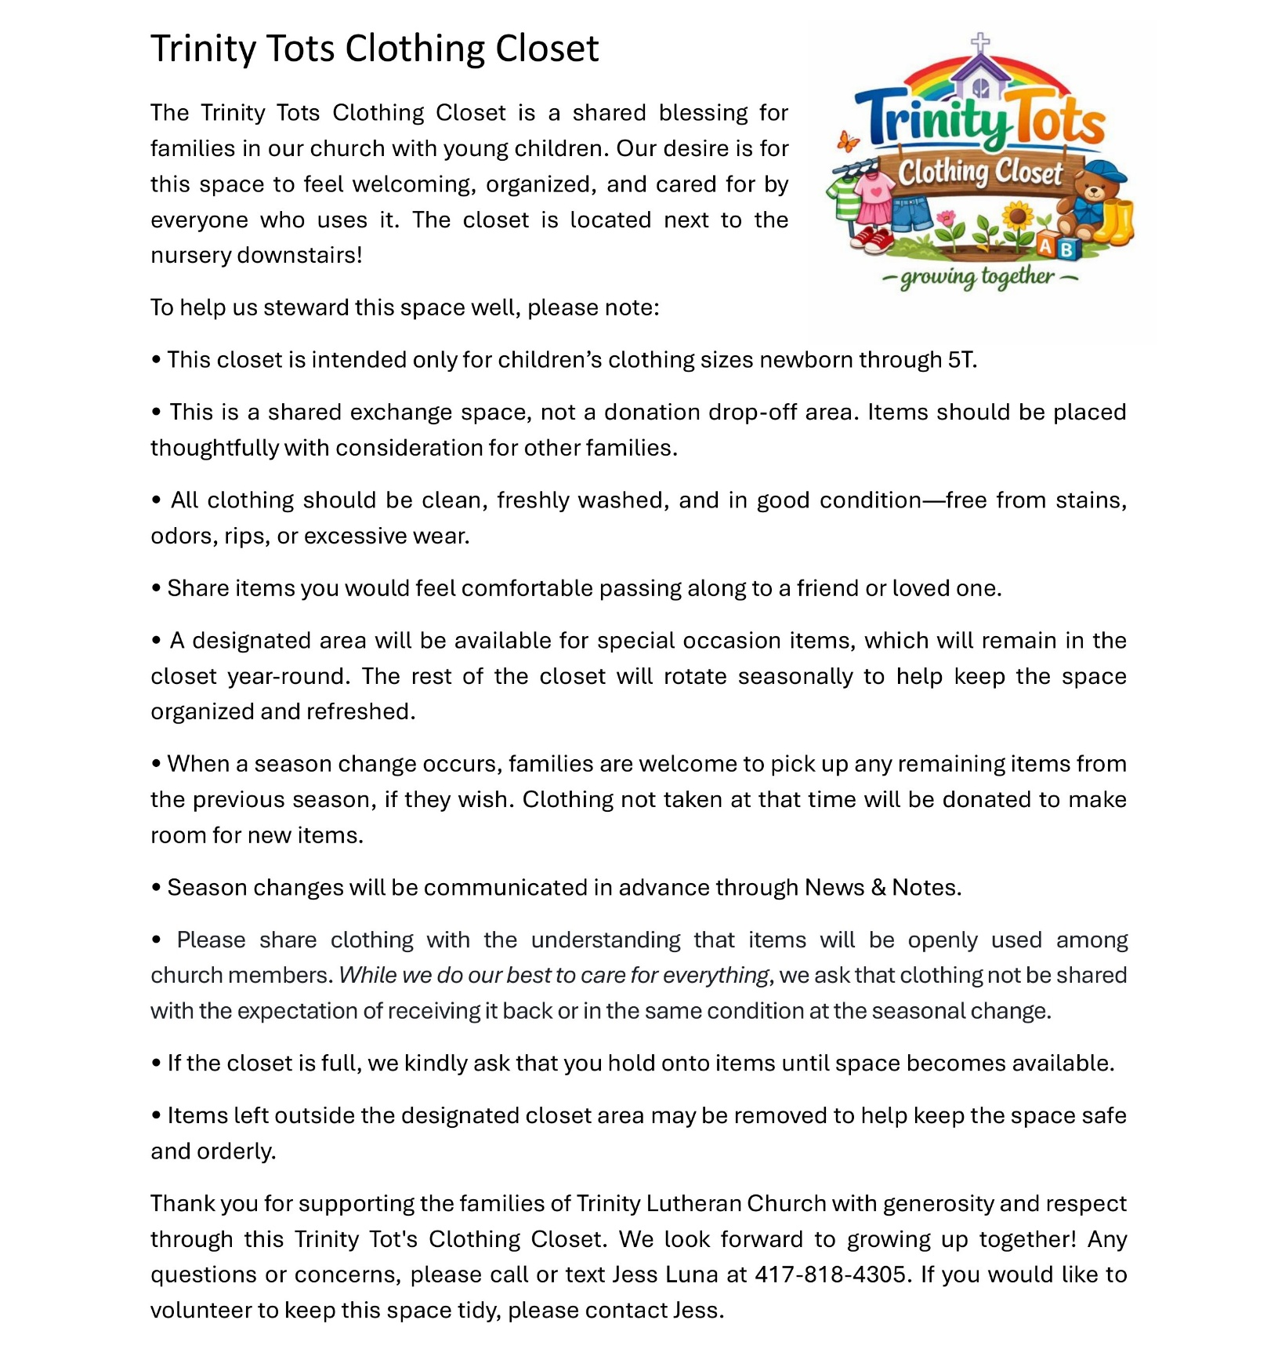







Sunday School Singers is looking for adult or youth volunteers to lead the kids' communion singing during service each week. Use the SignUpGenius QR code to sign up for Sunday services when you will be in attendance, or text Shannon Crosby at 417-597-5895 when you can help. Thank you to all of the volunteers who make this program possible!








A Special Invitation

Lutherans for Life
invites
ALL 7th and 8th grade students AND their parents to a special evening.
February 22nd, 2026
5:00 – 7:30 PM
Redeemer Lutheran Church
2852 S. Dayton Ave., Springfield, MO

It helps to have the tools to navigate HEALTHY RELATIONSHIPS.
It can be tough to know what to say, how to say it and when it is safe.
We want to help…speakers, information because we care.
All this and a Nacho Bar too.
Our treat for the students and a nominal price of $5 for parents.
We want to have enough Chips and Dip, so we must have an RSVP.
Contact Kim DeLuce
(417) 343-1126
Kdeluce3@gmail.com

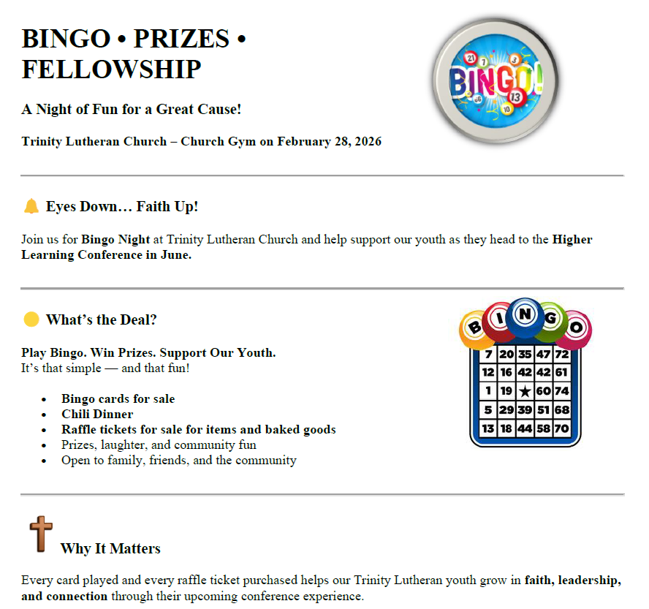
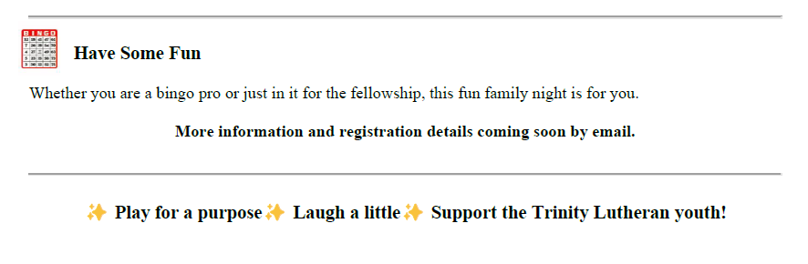
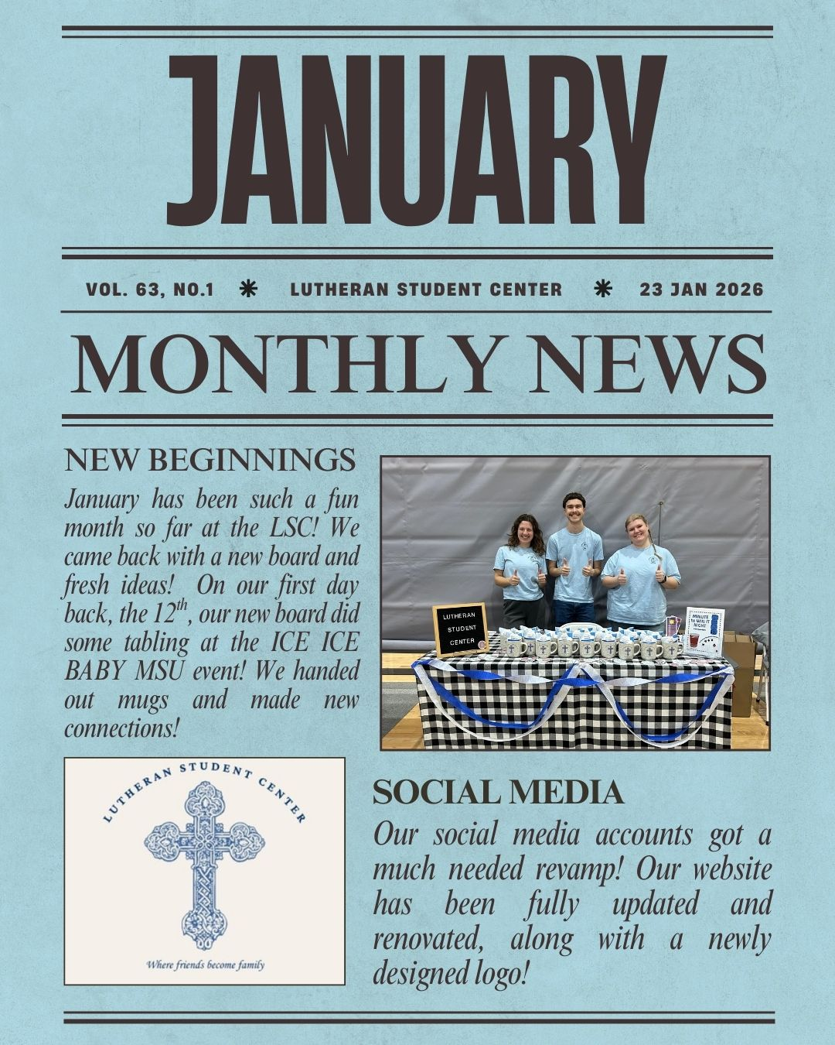
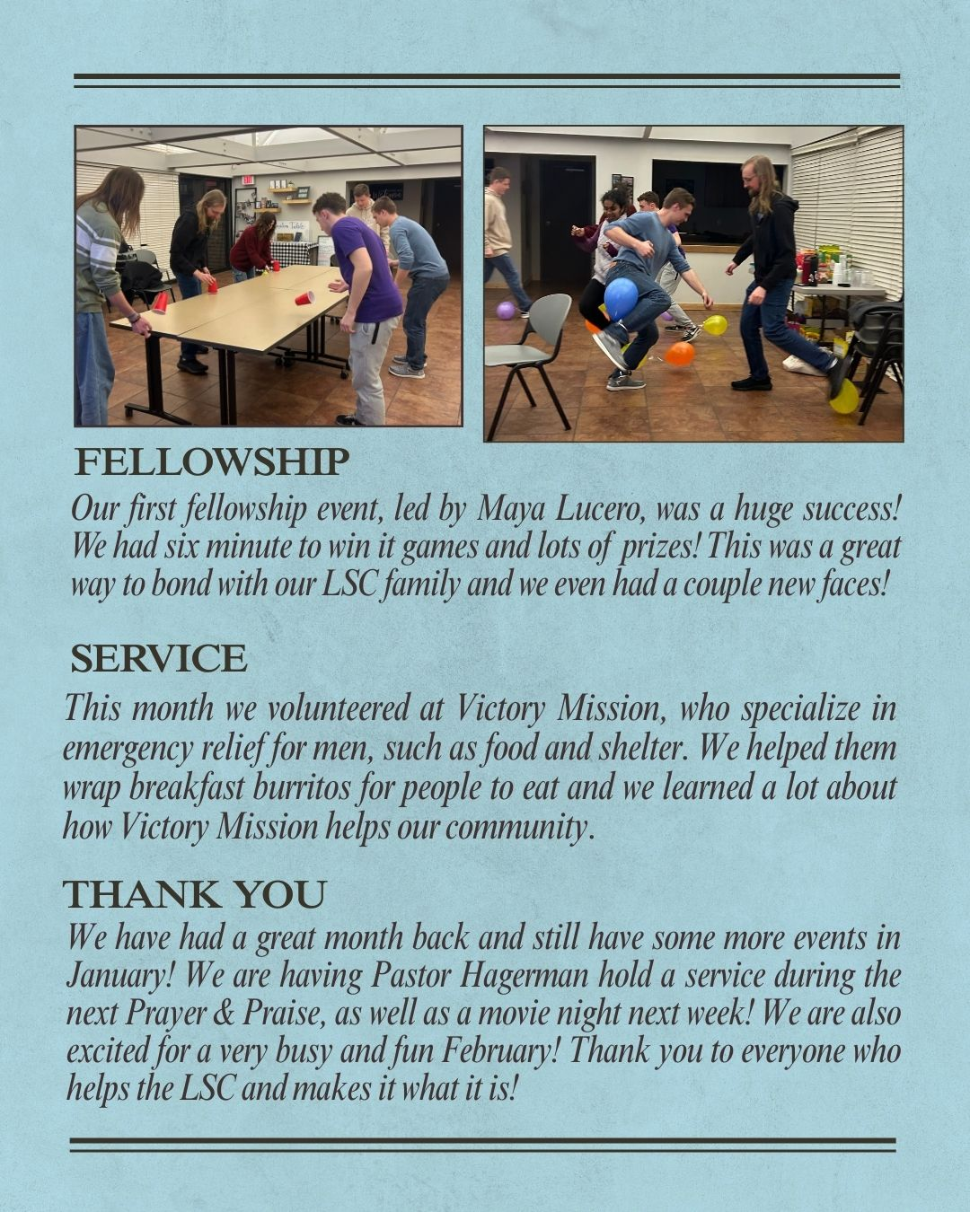





TRINITY FAMILY PRAYER PAGE
Each week immediate prayer needs are published in “The Trinity Family Prayer Page.” Each month in The Trumpet, those we pray for weekly as well as others with long term prayer needs are listed to be included in members’ personal and household devotions and prayers. . .if you’d like to add a family member or friend, please call or e-mail the Trinity office with your request. . .May God bless all for whom we pray. . .

For Those Coping With Cancer

Friends/Family of Trinity Members:
Ginnie Beaman, co-worker of Melinda Brown
Brad Brandt, brother of Nancy Spencer
Ramon DeArmas, friend of Bob & Lisa Schroeder
Wayne Forester, grandfather of Dakotah Gumm
Derald Eggerman, brother of Don Eggerman
Michelle Hicks, friend of Pam Osterloh
David Hoke, friend of Barbara Roehl
Carolyn Johnson, aunt of Carmen Boyd
Jenee Kernan, friend of Carl & Linda Oughton
Lawrence Kitchen, grandfather of Mandy Patton

Elaine Kruger, sister of Fran Wald
Melissa Larimore, daughter of Sheila Ankrom
Traci Prater, friend of Rich & Lu Crabtree
Dawn Price, friend of Dave & Joni Sommerer
Lynn Rogers, friend of Carmen Swinney
Sharon Schmidt, mother of Candace Gaede
Gene Schroeder, brother of Ben Schroeder
Rob Snyder, nephew of Sheila Ankrom
Jeremy Summers, nephew of Ernie Lewis
Gary Willliams, uncle of Candace Gaede

For Those Who Are Homebound in our Trinity Family
Members permanently or temporarily homebound. . .

Bob Bell
Phyllis Hansen
Georgia Mikessell
Kay Quasius
Paula Spalding
Jerry Williams

For Those Facing Ongoing Health Issues
Judy Becker
Frank Bennett
Marien Byrne
Carol Etherton
Easton Fitzgearlds
Joshua Gaede
Donna Gann
Roy Merritt
Pam Osterloh
Tim Peters
Kathy Polacoff
Dr. Grace St. Pierre
Albert Shook
Dave Sommerer
Friends/Family of Trinity Members:
Eli Applegate, grandson Ben & Deb Schroeder
Elise Drennan, great-niece of Debbie Shell
Jeril Heine, brother of Amy Johnson
Cheryl Kinkeade, sister of Linda Oughton
Verla Williams, aunt of Candace Gaede

For Our Nation and For Members of Our Armed Forces
We pray not only for the soldiers listed here, but also for their families!

Chris Adams
Phillip Hackley
Benjamin Schmidt
Robert Stillings, Jr.

Nick Costello, nephew of Mark & Karen Freiert
Frank Edling, son of Alfred Edling
William Jones, brother of Lauryn Peters
Kevin Myers, brother-in-law of Kathy Polacoff
Austin Peregory, nephew of Mark & Karen Freiert

Week of February 1-8, 2026
Today | The Fourth Sunday after Epiphany  8:15 & 11:00 a.m. Divine Services  9:30 a.m. Fellowship, gym  9:45 a.m. Sunday School & Adult Bible Class  12:30 p.m. Early Communion Forum, gym  5:00 p.m. Basketball, gym
Monday | 9:15 a.m. Faith Foundations Women’s Bible Study, gym  1:00 p.m. Church Office Opens  6:00 p.m. Elder’s meeting  Caleb Staehr’s day off
Tuesday | 6:00 p.m. Pickleball, gym  6:00 p.m. Prayer & Praise @ LSC
Wednesday | 10:45 a.m. Wednesday Morning Bible Class, gym  5:00 p.m. Midweek Meal  5:45 p.m. Kids of the Kingdom  6:00 p.m. 7th-8th grade class/ High School Class  6:30 p.m. Adult Catechism Bible Study, Heilman Room  6:30 p.m. 3rd-6th grade class/Good News Crew/Kindergarten/ Nursery
Thursday | 7:00 a.m. Men’s Bible Study, Room 2  12:30 p.m. College Bible Study, Travellers House on National  5:25 p.m. Choir Rehearsal  6:50 p.m. Bell Rehearsal
Friday | Church office closed  6:00 p.m. JH & Senior High Lock-In  Vicar Oloff and Daniel Duffy’s day off
Saturday | 2:30 p.m. M&M Pool Party, The OC, Ozark
Next Sunday  February 8 | The Fifth Sunday after Epiphany  8:15 & 11:00 a.m. Divine Services  9:30 a.m. Fellowship, gym  9:45 a.m. Midwinter Games, gym  9:45 a.m. Adult Bible Class, Woker Room/ Room 2/ Youth Room  5:00 p.m. Basketball, gym

