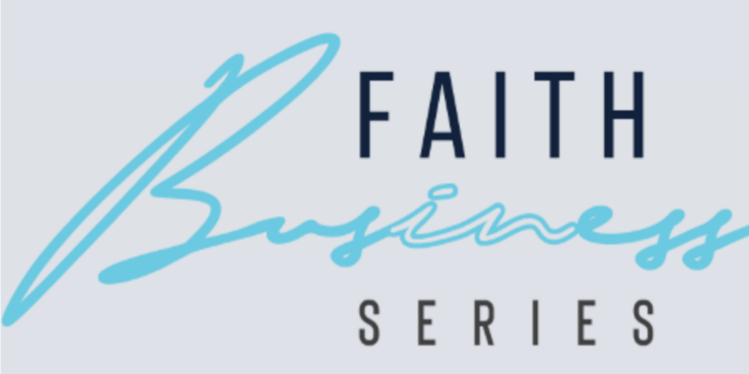
FAITH IN BUSINESS
As part of becoming more engaged in community events, I recently attended the Faith in Business event on March 10, 2026. The keynote speaker was Sarah Forhetz, who delivered a passionate and encouraging message about faith, leadership, and purpose in the workplace. It was a wonderful opportunity to connect with other like-minded business leaders in our community who are striving to live out their faith through their work.
I wanted to share my experience with the congregation and encourage you to consider attending the next event.
The next Faith in Business Series will take place on April 21, 2026, featuring keynote speaker Dr. Jeff Frederick, President of Drury University.
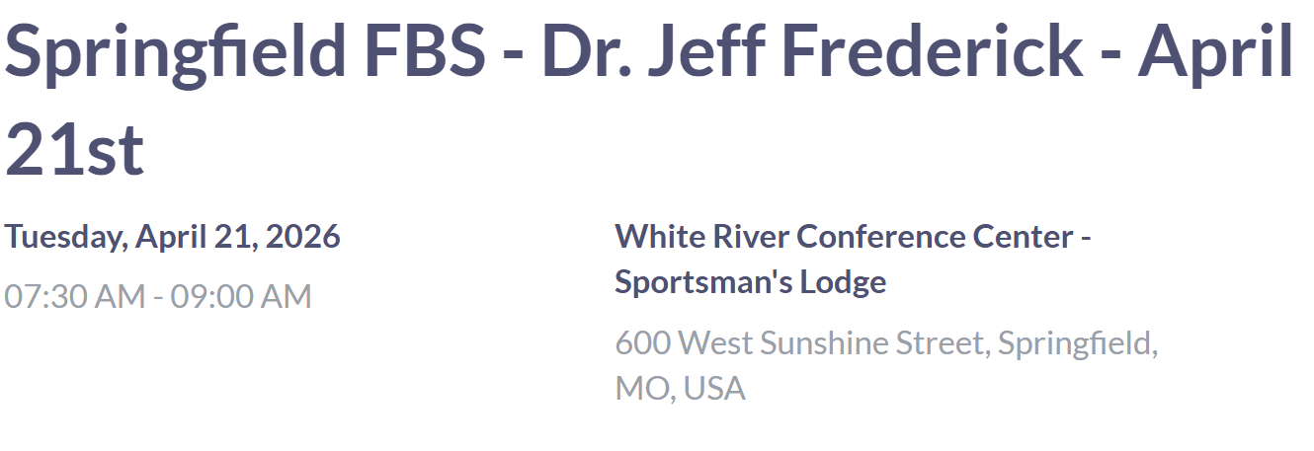
The event is free to attend, but registration is required in advance. Breakfast is provided and was excellent. It is a great opportunity for fellowship, encouragement, and networking with others in the Springfield business community.
Register here:
https://ticketbud.com/events/85e868a2-18cb-11f1-ad48-42010a71700b
I would love to see some familiar faces there next month.
Serving together in God’s Mission,
Jess Luna
Evangelism and Missions

