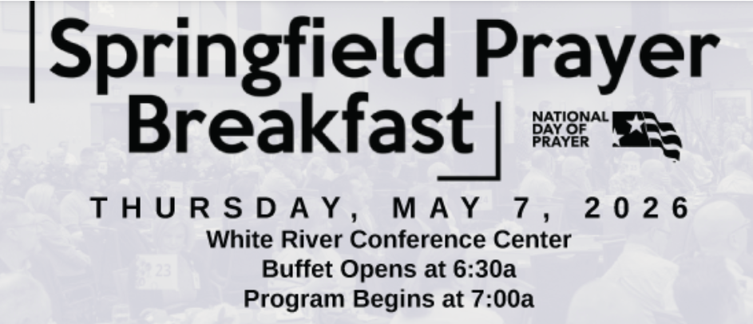
A Community Tradition of Prayer and Unity
You are invited to join fellow members of Trinity Lutheran Church and Christians from across the Springfield community for the annual Springfield Prayer Breakfast. This gathering brings together churches, community leaders, and local residents to pray for our city, state, and nation while strengthening relationships within the Christian community. Breakfast and program begin early morning, registration required.
If you are interested in attending, you must register and purchase a ticket. Cost: $15 per ticket.
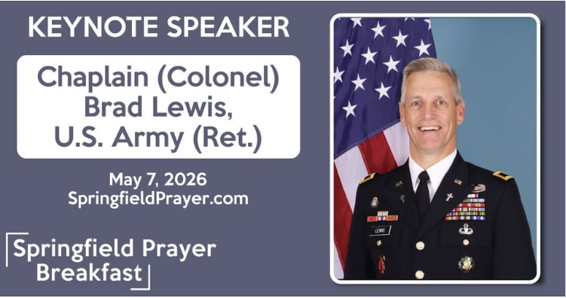
Why Attend?
• Join hundreds of believers from across the Ozarks in prayer
• Hear inspiring messages from community and faith leaders
• Connect with Christian professionals and churches in our area
• Represent Trinity Lutheran Church in a meaningful community event
This event has been a Springfield tradition for decades and is coordinated through the Council of Churches of the Ozarks.
Learn more or register online
https://www.facebook.com/SGFPrayerBreakfast/
Serving together in God’s mission,
Jess Luna
417-818-4305

