Faith Foundations 2023-2024
The Book of Ezekiel
Introductory Session

Welcome to Faith Foundations! I (Pastor Nick Hagerman) am excited to be teaching this class with all of you again after being off for the summer months. I’ve had a lot of fun with Faith Foundations the past two years, and I hope all of you have as well. I’m looking forward to continuing this Bible study’s long tradition of in-depth, serious study of the Scriptures.

Faith Foundations is a women’s Bible study that approaches the Scriptures from the perspective of Lutheran theology. What this means is that, first of all, we consider the Scriptures to be the inspired, inerrant, and authoritative Word of God. We do not believe that the Bible makes mistakes or that Christians are free to ignore its teachings when something else suits them better. The Bible is the basis for all of the doctrines of the Lutheran Church, and thus it will be treated as such in this study.

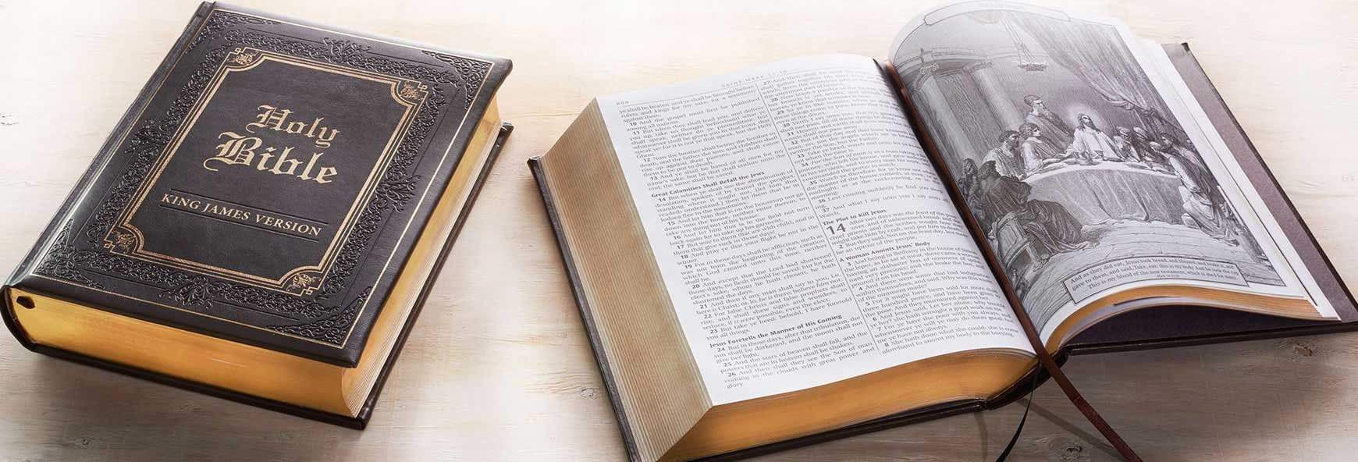

The Lutheran Church also considers the confessional documents found in the Book of Concord (i.e.—the Augsburg Confession, Martin Luther’s Catechisms, the Smalcald Articles, and the Formula of Concord) to be a faithful and true exposition of the Word of God. Hence, these will sometimes be referenced in this class, as will some writings of church theologians. The traditions of the church can never replace Scripture, but they can aid us in its interpretation. The Lutheran Church values the contributions that learned theologians have made to the understanding of the Bible over the years, and so we will use those traditions discerningly as we study the Scriptures together.

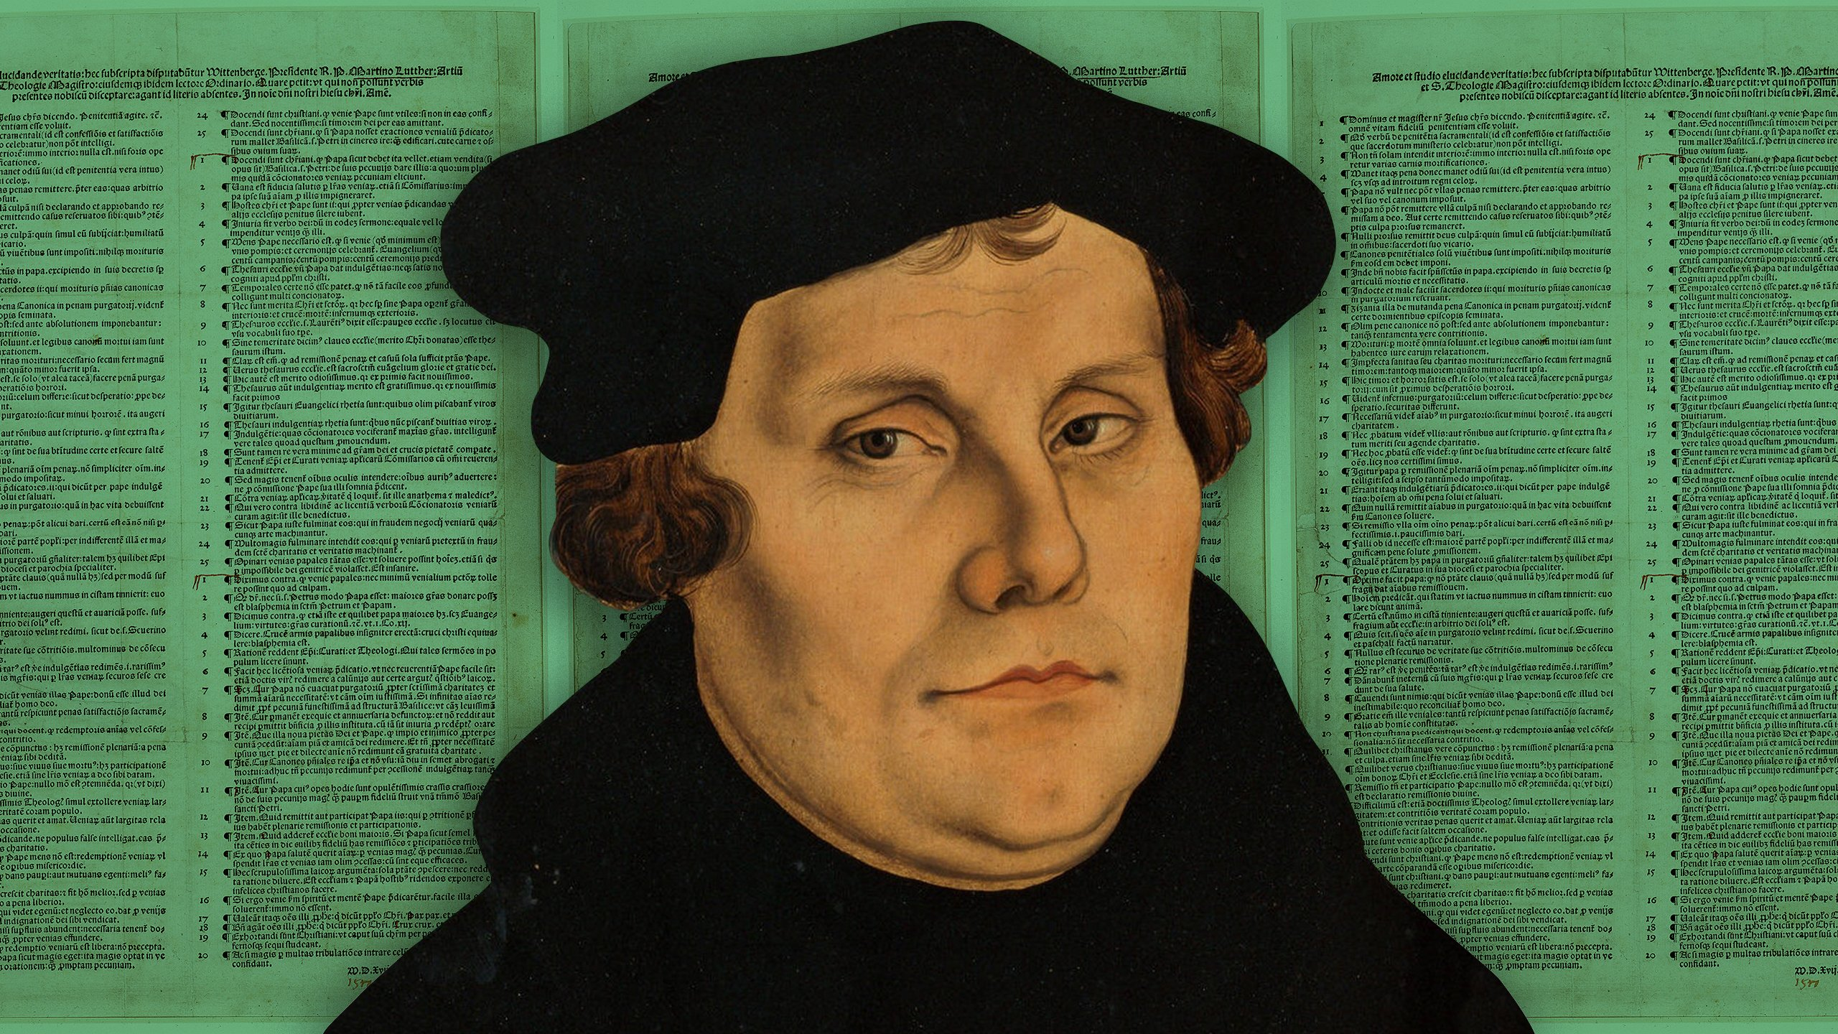
In this year’s Bible class, we will be studying one of the longest, and yet least-read, books of the Bible: the book of Ezekiel. Other than a few passages here and there, Ezekiel is not typically very well known among Christians. It contains a full forty-eight chapters, and yet only a couple of them would sound familiar to the average person in the pews. As such, it will serve as an excellent text for us to study this year, as it will expose many of us to parts of the Bible that we have never examined in depth.

For starters, what type of book of the Bible is Ezekiel?

When and where did Ezekiel conduct his ministry?

What was the occasion for Ezekiel’s ministry? Why did God commission him to prophesy?

Ezekiel’s ministry occurred during a pivotal time for the people of God in the kingdom of Judah. Their brothers in the northern kingdom of Israel had already been conquered by the Assyrians, and now Judah itself was being threatened by the Babylonians. If Judah wanted to avoid the same fate as Israel, then its leaders and people would need to repent of their sins and turn to the true God for deliverance. As we will see, however, this was much easier said than done.

In preparation for our study of Ezekiel itself, we will read several chapters from 2 Kings that will give us some much needed context for Ezekiel’s ministry.

Read 2 Kings 21:1-9. Who became king in Judah, and what kind of king was he?

Read 2 Kings 21:10-15. What did God promise to do to Judah because of Manasseh’s sin? What do Samaria and the house of Ahab have to do with this?

Read 2 Kings 22:1-2. Who later became king in Judah, and what kind of king was he?

Read 2 Kings 22:3-7. How did Josiah demonstrate his commitment to the true God?

Read 2 Kings 23:1-3. What did Josiah do before all the people? What did this action inspire in them?

Read 2 Kings 23:4-20. What did Josiah do to the idols and to the priests who worshiped them?

Read 2 Kings 23:21-25. What else did Josiah do in service to the true God of Israel?

How does verse 25 describe Josiah and his reforms?

Read 2 Kings 23:26-27. Did Josiah’s reforms have a lasting effect on Judah? Why or why not?

Unfortunately, things had already gone too far in Judah for Josiah’s reforms to truly take root in the hearts and minds of the people. Manasseh’s sin still stank in God’s nostrils, and God would not allow it to go unpunished. Plus, the people of Judah would only remain faithful as long as their king was faithful, which raised the question of what would happen when Josiah was no longer the king. As we will see, it wasn’t good.

Read 2 Kings 23:28-30. What happened to Josiah when he went to do battle with Pharaoh?

Read 2 Kings 23:31-35. Who became king in Judah after Josiah’s death? What kind of a king was he?

What happened to Jehoahaz at the hands of Pharaoh? Who became king in his place?

Read 2 Kings 23:36-24:7. What kind of king was Jehoiakim? What happened to him at the hands of Nebuchadnezzar?

Read 2 Kings 24:8-17. Who became king after Jehoiakim? What kind of king was he?

How long did Jehoiachin’s reign last? What happened to him and to Jerusalem under his rule?

Read 2 Kings 24:18-20. Who became king after Jehoiachin? What kind of king was he, and what did he do that ultimately led to Jerusalem’s doom?

Read 2 Kings 25:1-7. What did Nebuchadnezzar do to Jerusalem? What did he do to Zedekiah?

Read 2 Kings 25:8-21. What did Nebuchadnezzar do with the people of Jerusalem? What did he do with the treasures of Jerusalem, including those in the temple?

Because of Judah’s unfaithfulness to their God, He allowed its enemies to triumph over it and carry its people into exile in Babylon. As we just read, there were several deportations of Judahites from Judah to Babylon, and the prophet Ezekiel was among those taken in the deportation of Jehoiachin eleven years before Jerusalem’s final destruction. As such, his ministry occurred entirely in Babylon among the Judahite exiles, both before and after the fall of Jerusalem.

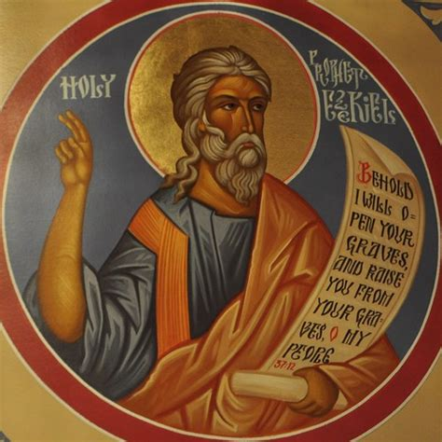

Over these next several months, we will have many opportunities to read the words of this prophet and see what he had to say to the people of his day. We will also see what he has to say to the people of God in the Christian Church in today’s world. The Word of God always speaks to His people, and the book of Ezekiel is no exception to that rule. In our reading of this book in Faith Foundations, we will find that it is far more applicable to us than we might have thought at first. May God bless our study of His Word this year!

